<https://onlinegdb.com/XPEkYRc1a>

Memory will be allocated in Heap area for Objects

Method will have

--Name

--Parameters

--Body

--Return Type

Ex:

int Cal(int a,int b)

{

return a+b;

}

class Cal{

int a,b,c;//These are instance Variables

void add()

{

a=10;

b=20;

c=30;

int d;//Local varaible

System.out.println(a+b+c);

}

}

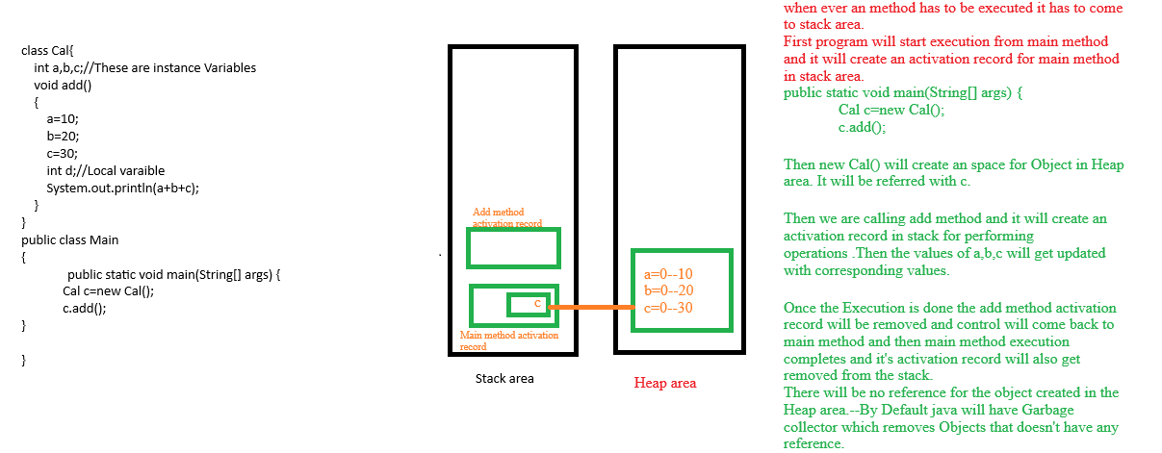

class Cal

{

int res;

void add (int a, int b)//Parameters

{

res = a + b;

System.out.println (res);

}

}

public class Main

{

public static void main (String[]args)

{

Cal c = new Cal ();

c.add (10, 20);//Arguments

}

}

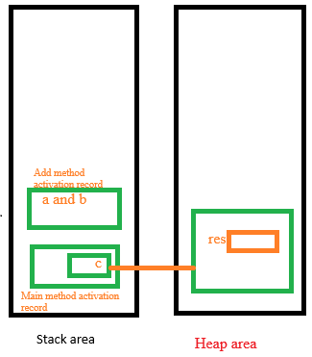

<https://onlinegdb.com/JcIlDvkoZ>

Ex:2

<https://onlinegdb.com/bn9_0-KaY>

Ex:3

<https://onlinegdb.com/dGr9fb18e4>

Ex:4

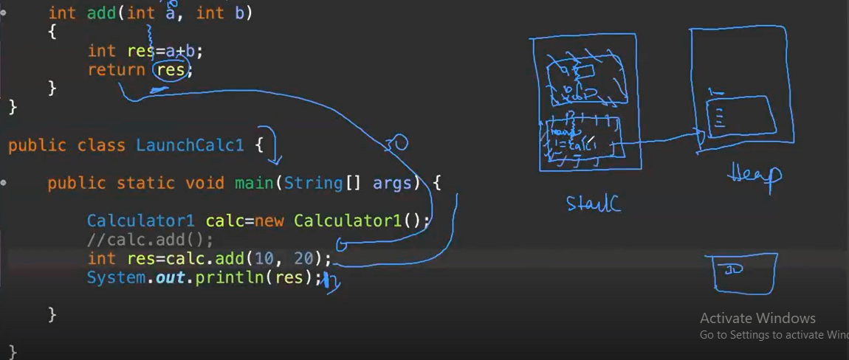

When a method is returning some value, it is not mandatory to collect.

But if a method is expecting any parameters, we need to pass them mandatorily.

<https://onlinegdb.com/YanuMWjqe>

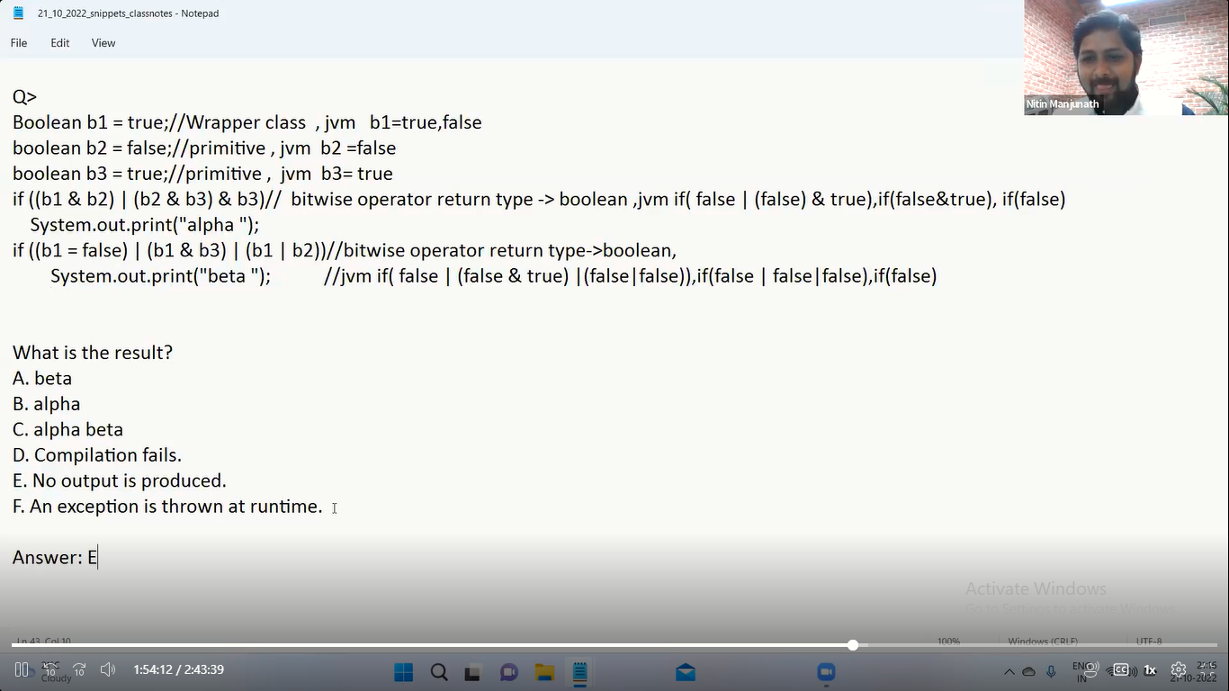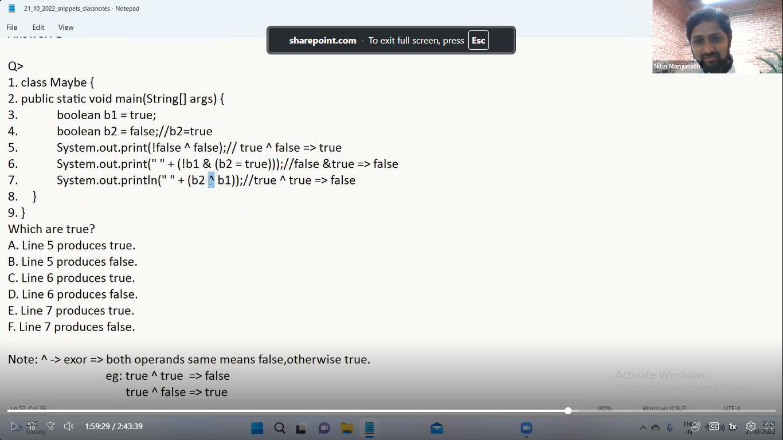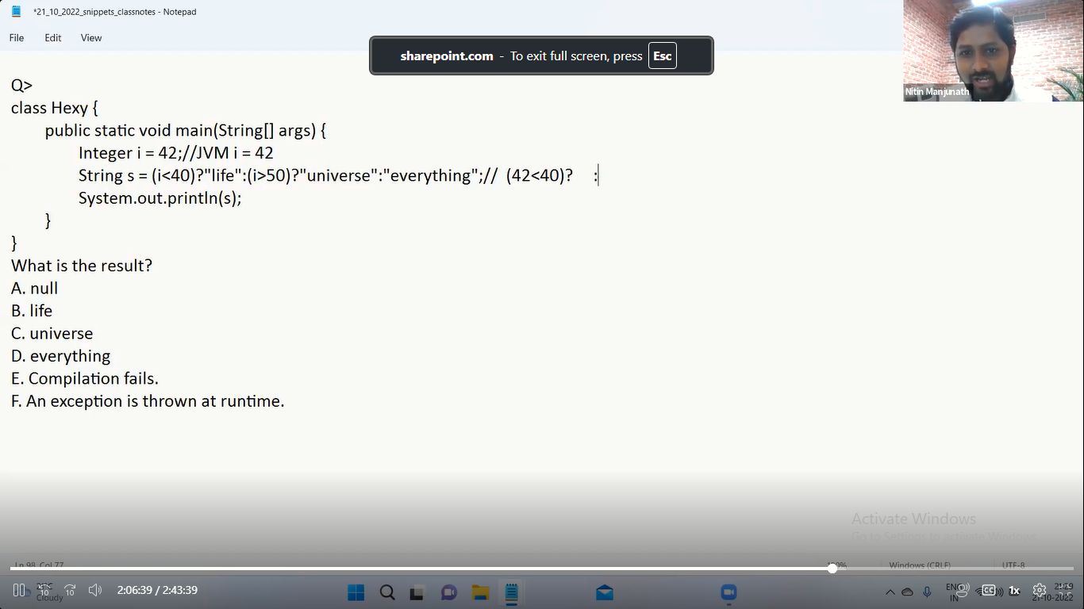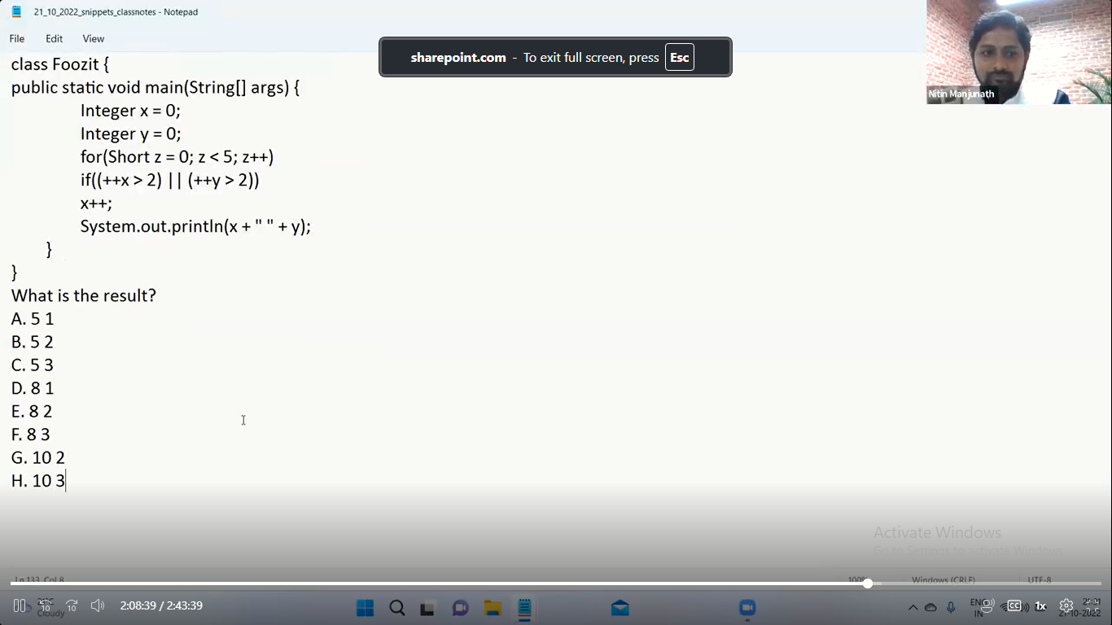x-0

y-0

k-0 to 4

0

if((++x>2)||(++y>2)

x++;

k=0

1>2||1>2

x=1 y=1

k=1

2>2||2>2

k=2

3>2||

x=4 y=2

k=3

5>2

x=6 y=2

k=4

7>2||

x=8 y=2

If the line is Ending ; then only it will be considered as statement

For()

If()

X++;

Entire above if is single statement.